Stem Cells Can Help Rebuild Joints
Posted: 08/19/2014 11:35 am EDT Updated: 08/19/2014 11:59 am EDT

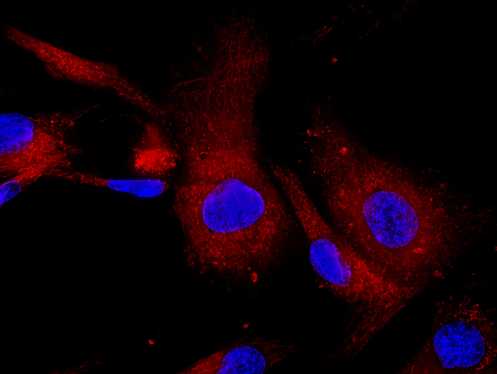
Mesenchymal stem cells labeled with fluorescence molecules
Harnessing stem cells to cure disease is the hottest topic in injury and arthritis treatment today. By stimulating the adult stem cells found in our own bodies, we can amplify and speed up the natural healing process as well as grow new bone and cartilage to rebuild joints without the need for artificial replacements [1].
When we are injured, our body immediately begins the process of healing itself. The trauma or impact from injury results in damaged tissue, ruptured blood vessels and sometimes broken bones. The body responds by releasing fluid and blood cells into the injured area, which causes swelling. This inflammation response essentially walls off the injured area [2].
Into this isolated zone certain blood cells, called platelets and macrophages, release bioactive molecules that guide the repair process. One of the most important of these molecules is called platelet-derived growth factor subgroup BB (PDGF-BB) [3]. This growth factor is able to release vital stem cells that live on the outside of the walls of our blood vessels. These stem cells, called mesenchymal stem cells (MSCs), play a critical role in tissue formation and healing [4]. Once freed from their attachments, the stem cells are able to move to the damaged area. The stem cells then begin their repair job by changing into the very cells that have been damaged and releasing additional specialized growth factors.
Adult stem cells are not the same, nor are they as controversial as embryonic stem cells. An embryonic stem cell is essentially a blank slate with the potential to turn into a huge variety of tissues, including, unfortunately, cancer cells. Adult stem cells are more limited. However, MSCs can differentiate into a number of musculoskeletal cell types, including bone, cartilage and tendon tissues.
For example, when the repair involves broken bones, new vessels invade, carrying with them layers of vessel-attached stem cells that evolve into bone-forming cells called osteoblasts. The molecule PDGF-BB stimulates the formation of new vessels and causes stem cells to release from the vessel walls and form bone cells.
When soft tissue is injured, the stimulating molecule causes the stem cells to form collagen, the base material of all tissue in the body. The rate of soft tissue or bone repair becomes at least partially dependent on the number of new vessels and the number of stem cells available. As people age, cell numbers start to drop and the healing is slower.
Stem cells can also help heal osteoarthritis. particularly post-traumatic arthritis. The condition is characterized by injury to the articular cartilage, the bearing surface covering the bone on the ends of joints. When the surface is injured, it heals poorly, if at all, because of the lack of blood supply. Techniques for stimulating cartilage repair, and cures for arthritis, focus on inducing a new blood supply often by fracturing the exposed bone [5,6].
The bone fracturing releases the stem cells in the bone marrow. The cells, and the factors they release, recruit a new blood supply and bone repair cells. When the cells are combined with a favorable healing environment, such as a paste of cartilage and bone, they then form new cartilage and repair the arthritic area. This technique, called articular cartilage paste grafting, is one of several techniques designed to repair cartilage and solve the arthritis problem [6,7].
It all works because the stem cells attached to the new blood vessels produce the new bone and cartilage under the guidance of the growth factors such as PDGF-BB. The older you get the more blood needs to brought to the healing site to increase the number of stem cells.
Injections of growth factors and stem cells are now possible and have shown promising results in treating some forms of cartilage repair and arthritis. When you hear of platelet-rich growth factor being injected into athletes to speed healing, the factor in the PRP that has the most effect may be the PDGF-BB, which starts the stem cell cascade of release from vessels, migration to injured site and remodeling of the injury. Generally, the dead arthritic areas need to be stimulated with a new blood supply first to have the maximal effect.
There is still much to be explored in the area of stem cells and regenerative orthopedics, and we are excited to be a part of it. Harnessing stem cells to speed healing and cure disease is a crucial part of injury and arthritis treatment today. We know that stem cells attached to your blood vessels can repair injuries. All they need is a little guidance.
References:
1. Pittenger MF, Mosca JD, McIntosh KR. Human mesenchymal stem cells: progenitor cells for cartilage, bone, fat and stroma. Curr Top Microbiol Immunol. 2000;251:3-11.
2. COTRAN RS, MAJNO G. THE DELAYED AND PROLONGED VASCULAR LEAKAGE IN INFLAMMATION. I. TOPOGRAPHY OF THE LEAKING VESSELS AFTER THERMAL INJURY. Am J Pathol. 1964;45:261-81.
3. Grazul-Bilska AT, Johnson ML, Bilski JJ, et al. Wound healing: the role of growth factors. Drugs Today (Barc). 2003;39(10):787-800.
4. Dimitriou R, Tsiridis E, Giannoudis P V. Current concepts of molecular aspects of bone healing. Injury. 2005;36(12):1392-404. doi:10.1016/j.injury.2005.07.019.
5. Frisbie DD, Oxford JT, Southwood L, et al. Early events in cartilage repair after subchondral bone microfracture. Clin Orthop Relat Res. 2003;(407):215-227.
6. Stone KR, Walgenbach AW. Surgical technique for articular cartilage transplantation to full thickness cartilage defects in the knee joint. Oper Tech Orthop. 1997;7(4):7.
7. Stone KR, Walgenbach AW, Freyer A, Turek TJ, Speer DP. Articular cartilage paste grafting to full-thickness articular cartilage knee joint lesions: a 2- to 12-year follow-up. Arthroscopy. 2006;22(3):291-299. doi:S0749-8063(05)01811-6 [pii] 10.1016/j.arthro.2005.12.051.

